**Functional Specification**

**CLICK SENSOR HUB**

**Project Manager: Alfonso de la Morena**

**Dylan Dean, Mohamed Sghari**

**Faculty Advisor: Dr. Stapleton**

**Texas State University**

**Ingram School of Engineering**

**SPONSOR NXP**

**6501 W WILLIAM CANNON DR**

**AUSTIN, TX 78735**

**10/15/2018**



|  |  |  |  |
| --- | --- | --- | --- |
| **Revision History** | | | |
| **Version** | **Date** | **Description** | **Author** |
| 0.1 | 09/19/2018 | Initial read and section assignment | Alfonso |
| 0.11 | 09/20/2018 | Finished Section | Dylan |
| 0.2 | 09/24/2018 | Start work on personal sections | Alfonso |
| 0.22 | 09/25/2018 | Finished Section | Dylan |
| 0.3 | 09/26/2018 | Finished Section | Dylan |
| 0.31 | 09/26/2018 | Start working on terminology used | Mohamed |
| 0.32 | 09/27/2018 | Start working on diagram | Mohamed |
| 0.33 | 09/28/2018 | Finished Section | Dylan |
| 0.4 | 09/28/2018 | Add Diagrams and work on sections | Alfonso |
| 0.41 | 09/30/2018 | Finished Section | Dylan |
| 0.42 | 10/03/2018 | Finished Section | Dylan |
| 0.5 | 10/03/2018 | Interface of FRDM and Clicks | Mohamed |
| 0.6 | 10/04/2018 | Edited document wording and worked on sections 2.1, 2.7 and 2.8 | Alfonso |
| 0.7 | 10/11/2018 | Incorporate sponsor suggestions | Alfonso |
| 0.71 | 10/11/2018 | Incorporate sponsor suggestions | Dylan |

Table of Contents

1 Introduction 4

1.1 Summary 4

1.2 Customer Requirements 4

1.2.1 Deliverable #1 5

1.2.2 Deliverable #2 5

1.2.3 Deliverable #3 5

1.3 Existing System 6

1.4 Terminology 7

2 Functional Description 8

2.1 User Attributes and Use Cases 10

2.2 Administration Functions 11

2.3 Error Handling 11

2.4 Safety and Security 12

2.5 Help and User Documentation 12

2.6 Interfaces 13

2.6.1 User 13

2.6.2 Software 13

2.6.3 Hardware 13

2.6.4 Mechanical 17

2.7 Boundary Conditions and Constraints 17

2.8 Performance 19

2.9 Software Platforms 21

2.10 Service, Support, & Maintenance 21

2.11 Expandability or Customization 21

3 Project Alignment Matrix 22

4 References 23

5 Approvals 24

# **Introduction**

Alfonso de la Morena:

The Click Sensor Hub Project will design a PCB that allows connection between the FRDM-KL46Z and four MikroBUS standard sockets. Having access to MikroBUS sockets allows users of the FRDM-KL46Z to gain access to over 250 Click sensors that can be used in a myriad of development projects.

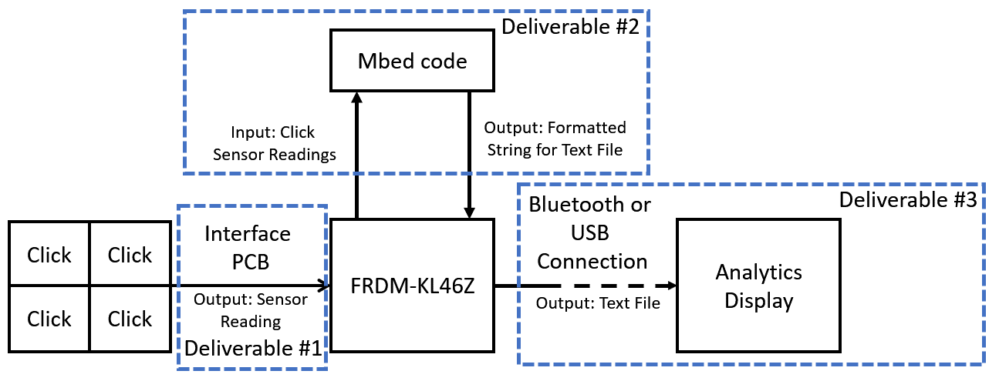

Figure 1: High Level Project Scope Block Diagram

## Summary

Alfonso de la Morena:

The Click Sensor Hub Project will create a PCB interface for one FRDM-KL46Z connect to four MikroBUS sockets. The FRDM-KL46Z is a development board made by NXP and the MikroBUS sockets allow connection to Click boards, which are add-on boards for interfacing microcontrollers with peripheral sensors or transceivers. From the over 250 Click sensors currently available, this project will be choosing 10 Clicks and writing the necessary code for the FRDM-KL46Z to interpret each of the Click board’s data. Once the interface is functional, the data will be collected and presented in a data analytics platform.

## Customer Requirements

Alfonso de la Morena:

Ultimately, our goals aim to provide an open source platform that provides the use of one to four MikroBUS sockets on the FRDM-KL46Z. All the designs, source code and an instruction manual will be provided free of cost. Additionally, the project will be posted in the community forums of NXP, Mbed and MikroElektronika.

### Deliverable #1

The goal of this deliverable is the creation of a PCB that includes one socket for a FRDM-KL46Z that connect to four MikroBUS standard sockets. The MikroBUS standard allows interface connections for SPI, IIC, Analog and PWM. Depending on the Click, it can either use one or all four of those interface connections. It is not as simple as connecting the interface pins to the FRDM-KL46Z because it has a maximum of 2 SPI, 1 IIC, 1 Analog and 1 PWM interface connection points. The solution this project will use will be to include a switching capability on the PCB that selects any one of the MikroBUS sockets individually.

From a customer’s perspective, they will have the ability to utilize one, two, three or all four of the MikroBUS sockets. The PCB is design to handle any combination of MikroBUS standard devices.

### Deliverable #2

In the second part of the project, the focus will be on writing code for devices that use the MikroBUS sockets to communicate with the FRDM-KL46Z. Particularly, the focus will be on Clicks. Using the Mbed compiler, code will receive the sensor readings from any of MikroBUS interfaces (SPI, IIC, Analog or PWM) and convert that reading into a formatted string that gets stored in a text file. For this section to succeed, a minimum of 10 Clicks will be tested and have code written for them to work.

From a customer’s perspective, once they have connected the FRDM-KL46Z and Click sensor(s) to the board, they will be able to use the project’s available source code to easily transfer the readings from the Click devices to a text file.

### Deliverable #3

The final deliverable in this project will take place once the board and the code are both functional. It aims to showcase an example of the usefulness of the product in real world application. Using the Click boards from previous sections, data will be interpreted by the FRDM-KL46Z and sent to a text file on a host computer. From there, the computer will use an analytics platform, such as Excel or Tableau, and visually display the data in a readable format. As a stretch goal for this section, the team would like to create a website that periodically accesses the text file to display the data. This would also create a good opportunity to have all the source code, related documents and project instructions in one place.

From a customer’s perspective, they will have the opportunity to see a real-world application of the Click Sensor Hub project. They will be able to see how the readings were interpreted from the text file. Additionally, if the stretch goal of a website is met, they will have access to all the HTML, CSS and JavaScript source code.

## Existing System

Alfonso de la Morena:

There is no current system for what this product aims to accomplish. The Click Sensor Hub will solve the existing problem of not having a platform to interface between the FRDM-KL46Z and four MikroBUS standard sockets. Making this product for less than three MikroBUS sockets would have made no practical sense since the FRDM-KL46Z is capable of handling two MikroBUS sockets via its existing pins. There is no need to create a PCB if you are simply trying to utilize two MikroBUS sockets. In addition, of the PCB to have the ability to take readings from one socket at a time could be expanded in the future to work for more than four MikroBUS sockets.

## Terminology

Mohamed Sghari:

|  |  |
| --- | --- |
| **Term** | **Description** |
| FRDM-KL46Z | A microprocessor board by NXP, it will be programmed using ARM Mbed OS 5.10. |
| ARM Mbed | A platform and operating system for connecting devices and embedded devices based on 32-bit ARM Cortex-M microcontrollers. |
| Printed circuit Boards (PCB) | A printed circuit board that provide connections to electronic components using conductive tracks, pads and other features etched from sheet layers of copper. |
| MAX14830 | An advanced quad universal asynchronous receiver-transmitter. Each UART is having 128 words of receive and transmit first-in/first-out and a high-speed serial peripheral interface or controller interface. |
| SC16IS752 | A semiconductor ship that has a dual-channel high performance universal asynchronous receiver-transmitter.it offer data rate up to 5Mbit/s and provide application with 8 additional programmable I/O pins. |
| 33999 Ship | A semiconductor ship comes with 16-output low-side switch with SPI and PWM control. It interfaces with microcontrollers and it’s compatible with both 3.3 V and 5.0 V CMOS logic levels. |

# **Functional Description**

Mohamed Sghari and Dylan Dean

Most of the functional applications of the Click Sensor Hub come from the Clicks themselves. The Clicks provide sensing capabilities that are sent to the FRDM-KL46Z so that it may process the data and later send it to a web display. A high-level outline of this behavior can be seen in the figure below.

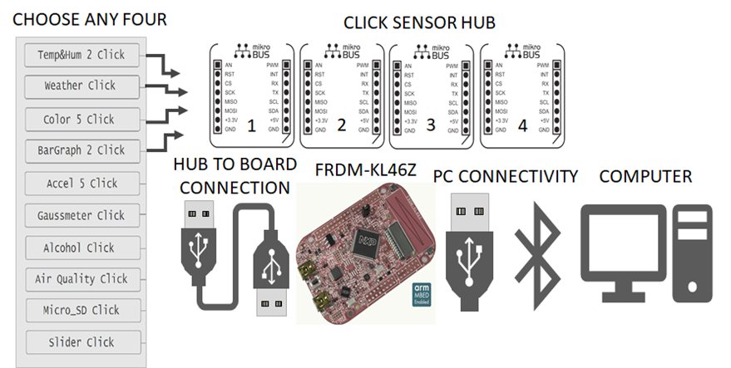

Figure 2: Basic Design Flow Diagram

As can be seen, the Click Sensor Hub is a mediator between the collection of data using Click boards and the use of that data for computations or other visual applications. The uses of the Click Sensor Hub depend on the user and allow a great range of customizability. The Clicks will perform a variety of functions. A general outline of these functions can be seen in the table below. Additionally, the table also specifies the rice and interface connection of each Click.

Table 1: Click Descriptions and Information

|  |  |  |  |  |
| --- | --- | --- | --- | --- |
| **Features** | **Sensor Name** | **Description and Interface** | **Reference** | **Price** |
| [Temp&Hum 2 Click](https://www.mikroe.com/temphum-2-click) | Si7034 | Measures a wide range of temperature and relative humidity values with a great accuracy   * 1.8 V Power supply * I2C interface | [1] | $16.00 |
| [Weather Click](https://www.mikroe.com/weather-click) | BME280 | Detects humidity, pressure, and temperature   * 3.3V Power supply * SPI or I2C interface | [2] | $22.00 |
| [Color 5 click](https://www.mikroe.com/color-5-click) | P12347 | Integrated color sensing device   * 3.3V and 5V Power supply * I2C interface | [3] | $16.00 |
| [BarGraph 2 Click](https://www.mikroe.com/bargraph-2-click) | SN74HC595 | 10-segment bar graph display click, which uses a high-quality, multicolor bar graph LED display   * 3.3V Power supply * PWM or SPI interface | [4] | $19.00 |
| [Accel 5 click](https://www.mikroe.com/accel-5-click) | BMA400 | Triaxial accelerometer sensor   * 3.3V Power supply * I2C or SPI interface | [5] | $19.00 |
| [Gaussmeter click](https://www.mikroe.com/gaussmeter-click) | MLX90393 | Gaussmeter click is a device that is used for measuring the magnetic field in X, Y and Z axes   * 3.3V Power supply * I2C or SPI interface | [6] | $19.00 |
| [LightRanger 3 Click](https://www.mikroe.com/lightranger-3-click) | RFD77402 | Accurate distance measurement based on a ToF (Time of Flight) measurement principle   * 3.3 V Power supply * I2C interface | [7] | $24.00 |
| [Alcohol Click](https://www.mikroe.com/alcohol-click) | MQ-3 | Portable alcohol detector, breathalyzer for estimating BAC   * 3.3V Power supply * Analog interface | [8] | $15.00 |
| [Air Quality Click](https://www.mikroe.com/air-quality-click) | MQ-135 | detecting a variety of gases that impact air quality in homes and offices   * 3.3V Power supply * Analog interface | [9] | $16.50 |
| [microSD click](https://www.mikroe.com/microsd-click?search_query=sd+card+click&results=6) | SD | A microSD card slot for microSD cards used as a mass storage media for portable devices   * 3.3 V Power supply * SPI interface | [10] | $16.00 |

## User Attributes and Use Cases

Alfonso de la Morena:

One of the key benefits of the Sensor Hub is its adaptability to the needs of the user. As such the general use case scenario can vary depending on the intended use of the product. The following entails the general steps needed to make use of the Sensor Hub.

|  |  |
| --- | --- |
| **Step 1** | Identify which Clicks are needed for your specific needs. |
| **Step 2** | Connect a maximum of 4 Clicks to the PCB and power the board. |
| **Step 3** | User the provided libraries to write code that detects data, following the constraints set by each Click, the FRDM-KL46Z and the PCB. |
| **Step 4** | Gather the data in FRDM-KL46Z and transmit it at a rate set by cable or wireless to your selected data base (not provided in the scope of this project). |
| **Step 5** | Analise, gather or display the data in a medium of your choice. |

The steps to use the product are intentional vague. The product, in its current state, is made for users with an existing level of engineering knowledge in the use of microprocessors. It is meant to work as a medium between users of the FRDM-KL46Z and Click sensors.

The following diagrams entail typical behaviour of the system when handling errors:

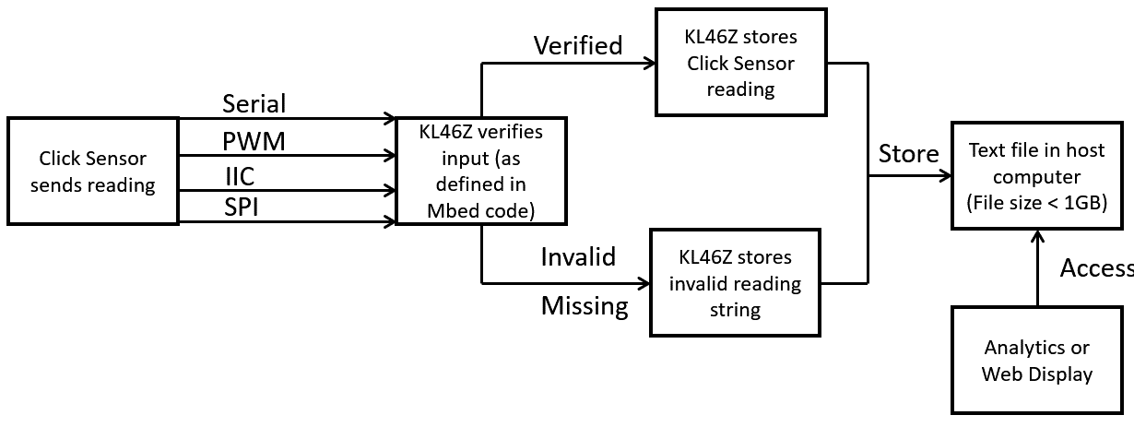

Figure 3: How System Handles Incorrect or Missing Readings from Click Sensors

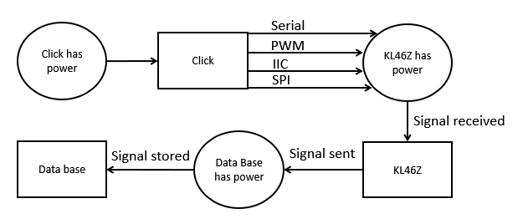

Figure 4: How System Handles Power Issues

As can be seen in Figure 4. The Click Sensor Hub is continuously storing its results in the data base. In the event of a loss of power at any of these points, the currently measured signal would fail to be stored. However, all signals before such an event should not be affected by the loss of power.

## Administration Functions

Dylan Dean:

N/A

*All users have access to FRDM-KL46Z system functions; no username or password is required. Users will also have access to any purchased Click system function; and open usage of the sensor hub. No user restrictions other than illegal device tampering laws which are stipulated on an individual device basis by company legal disclaimers and appropriate government bureaus.

## Error Handling

Dylan Dean:

All electronic systems have a potential for errors. The greatest challenge is getting the modular docking system to properly interface with any selected clicks. This should be handled with both hardware and software. On the hardware side, chips that expand upon limited pin outs on the FRDM-KL46Z are going to be a must. On the software side, proper code parameters will need to be set to adapt accordingly to the given click function and operational voltage limit.

Table 2: Common Errors with Handling Descriptions

|  |  |
| --- | --- |
| **Potential Error Cases** | **How to Handle Error Case** |
| 1. Logical Error in the board caused by a signal delay, loss or overflow. | Create a data signal Query, Create multiple data clone instances with a set time. |
| 1. Board Voltage exceeds maximum limit of 3.3V | Handled by placing a voltage limiter in the hardware, i.e. a Zener Diode and including software code for max voltage error flag and its appropriate response protocol. |
| 1. No Network Connection | Reset Router or Use Global device reset. |
| 1. Battery Low | Use provided power cable or replace battery |
| 1. Storage Media Not Found | Display Error message ask user to input the SD card. |
| 1. Storage Media Full | Display Error message ask user to empty the SD card. |
| 1. Sensor Readings Out of Bounds | Code operation boundaries and control parameters for every click that has been selected. |

## Safety and Security

Dylan Dean:

Safety risks to consider:

* There are no significant heating risks on the PCB, it will not thermally harm the device components or user. The FRDM-KL46Z microcontroller operating voltage range is (1.71V-3.6V) and consumes 25mA. The Click Sensor Hub will not consume more power than the than the FRDM-KL46Z. However, a heatmap will be generated as further evidence that both boards are not a safety risk.

Security risks to consider:

* There are no significant security risks with the project because no personal information is being used and the device is an open IoT development kit. Also, for now the device is strictly for instructional purposes at Texas State University.
* The NXP Product Security Incident Response Team (PSIRT) responds to reported security vulnerabilities in NXP products. A link is provided detailing their security process. If there is a security issue with the FRDM-KL46Z refer to the following in the reference page of the document. [11]

## Help and User Documentation

Dylan Dean:

A User Guide for sensor hub will be provided, with the following instructions for students.

* How to download Mbed OS
* Quick reference guide for FRDM-KL46Z
* Quick reference guide for Click Sensor Hub
* Data Sheets for each Click
* How to get Bluetooth Connectivity
* How to access data from SD card
* Troubleshooting Errors
* Safety Warnings/Hazards
* Legal Disclaimers

Help and User Documentation required for the FRDM-KL46Z platform is handled by NXP. [12]

## Interfaces

### User

Dylan Dean:

Deferred to design specification stage. In summary, the users for this project are varied. The Click Sensor Hub is meant to be open source and have any number of people build their own projects using the technology this project will provide.

### Software

Dylan Dean:

Arm Mbed OS 5.10 or most recent compatible OS, will be used to program FRDM-KL46Z.

* Code will be implemented through a physical Micro USB connection

SD card will be used to gather data collected from clicks.

* Data can be stored on the storage device and transferred to a PC.

### Hardware

Mohamed Sghari:

The hardware used in this project will, for the most part, be purchased. The Click Sensor Hub aims to provide a medium between two already existing and tested technologies: the FRDM-KL46Z and the devices using the MikroBUS standard. In the following figure the layout of the MikroBUS standard is shown. As can be seen, many of the pins can be shared among the different Click boards.

Additionally. The pins that will be shared as well as some additional functionality is displayed in the tables that follow. Also included is the specific pin assignments to be used when designing the PCB. There will be great care that the FRDM-KL46Z will utilize the necessary pins and that everything will be near the MikroBUS sockets.

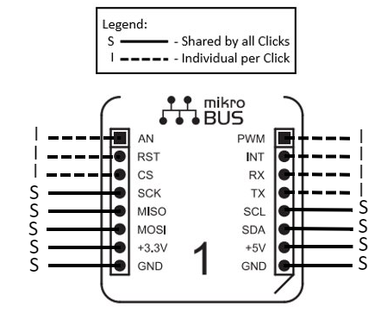

Figure 5: Pin Layout for mikroBus Standard Socket within PCB [13]

Table 3: Descriptions of Acronyms used in Figure 2

|  |  |
| --- | --- |
| **Acronym** | **Description** |
| AN | Analog |
| RST | Reset |
| CS | SPI Chip Select |
| SCK | SPI Clock |
| MISO | SPI Master Input Slave Output |
| MOSI | SPI Master Output Slave Input |
| PWM | PWM output |
| INT | Hardware Interrupt |
| RX | UART Receive |
| TX | UART Transmit |
| SCL | IIC Clock |
| SDA | IIC Data |
| GND | Reference Ground |

Table 4: FRDM-KL46Z Pin Assignment [12]

|  |  |  |  |  |  |  |
| --- | --- | --- | --- | --- | --- | --- |
| **Header** | **KL46 Ports** | **Arduino compatibility** | **Pin #** | **Pin #** | **KL46 Ports** | **Arduino compatibility** |
|  | PTA1 | D0/RX/int | 2 | 1 | PTB18 | I2S_TX_BCLK |
|  | PTA2 | D1/TX/int | 4 | 3 | PTB19 | I2S_TX_FS |
|  | PTD3 | D2/int | 6 | 5 | PTC0 | I2S_TXD |
|  | PTA12 | D3/PWM/int | 8 | 7 | PTC4 | I2S_MCLK |
| **J1** | PTA4 | D4/int | 10 | 9 | PTC6 | I2S_RX_BCLK |
|  | PTA5 | D5/PWM/int | 12 | 11 | PTC7 | SOF_OUT |
|  | PTC8 | D6/PWM/CMP/int | 14 | 13 | PTC10 | I2S_RX_FS |
|  | PTC9 | D7/CMP/int | 16 | 15 | PTC11 | I2S_RXD |
|  | PTA13 | D8/Input Capture/int | 2 | 1 | PTC13 |  |
|  | PTD2 | D9/PWM/int | 4 | 3 | PTC16 |  |
|  | PTD4 | D10/SPI_SS/PWM/int | 6 | 5 | PTA7 |  |
|  | PTD6 | D11/MOSI/int | 8 | 7 | PTA6 |  |
| **J2** | PTD7 | D12/MISO/int | 10 | 9 | PTA14 |  |
|  | PTD5 | D13/SCK/LED/int | 12 | 11 | PTA15 |  |
|  | ------------ | GND | 14 | 13 | PTA16 |  |
|  | ------------ | AREF | 16 | 15 | PTA17 |  |
|  | PTE0 | D14/SDA/Ana | 18 | 17 | PTB9 |  |
|  | PTE1 | D15/SCL/Ana | 20 | 19 |  |  |
|  | P5-9V | P5-9V | 16 | 15 | PTE2 |  |
|  | GND | GND | 14 | 13 | PTE3 |  |
|  | GND | GND | 12 | 11 | PTE6 |  |
|  | P5V_USB | P5V_USB | 10 | 9 | PTE16 |  |
| **J3** | P3V3 | P3V3 | 8 | 7 | PTE17 |  |
|  | RST | RESET_TGTMCU | 6 | 5 | PTE18 |  |
|  | P3V3 | P3V3 | 4 | 3 | PTE19 |  |
|  | SDA-PTD5 | SDA-PTD5 | 2 | 1 | PTE31 |  |
|  | PTC1 | A5/SCL/int | 12 | 11 | PTE30 | DAC_OUT |
|  | PTC2 | A4/SDA/int | 10 | 9 | PTB20 | CMP_OUT |
| **J4** | PTB3 | A3 | 8 | 7 | PTE23 | DIFF_ADC1_DM |
|  | PTB2 | A2 | 6 | 5 | PTE22 | DIFF_ADC1_DP |
|  | PTB1 | A1 | 4 | 3 | PTE21 | DIFF_ADC0_DM |
|  | PTB0 | A0 | 2 | 1 | PTE20 | DIFF_ADC0_DP |

Table 5: FRDM-KL46Z Port Availability [12]

|  |  |  |  |
| --- | --- | --- | --- |
| **Number of Pin** | **Port name** | **Number of Pin** | **Port name** |
| 2 | USB | 6 | PWM *Pulse Width Modulation* |
| 2 | SPI *Serial Peripheral Interface* | 6 | ADC *Analog-to-Digital* |
| 2 | I2C *Inter-Integrated Circuit* | 1 | DAC 6-Bit *Digital to Analog* |
| 1 | I2S *Inter-IC Sound* | 1 | DAC 12Bit *Digital to Analog* |
| 3 | UART *Universal Asynchronous receiver-transmitter* | 84 | GPIO *General Purpose Input/output* |

Table 6: Click Mikro BUS’PIN Layout [12]

|  |  |  |  |
| --- | --- | --- | --- |
| **PIN function** | **PIN iD** | **PIN iD** | **PIN Function** |
| Analog | AN | PWM | PWN output |
| Reset | EST | INT | Hardware Interrupt |
| SPI chip Select | CS | RX | UART Receive |
| SPI Clock | SCK | TX | UART Transmit |
| SPI  Master input  Slave output | MISO | SCL | I2C clock |
| SPI  Master output  Slave input | MOSI | SDA | I2c data |
| VCC – 3.3V Power | +3.3V | +5V | VCC – 5V Power |
| Reference Ground | GND | GND | Reference Ground |

Table 7: Shared and Unique Pins in PCB Design

|  |  |
| --- | --- |
| **Click Connection** | **Connection Type** |
| GND | Shared |
| 3.3V 5V | Shared |
| SPI: SCK  SPI: MOSI  SPI: MISO | Shared |
| I2C SCL  I2C SDA | Shared |
| Analog | Unique |
| PWM | Unique |
| SPI: CS | Unique |
| INT | Unique |
| RS232 (TX, RX) | Unique per clock |

### Mechanical

Dylan Dean:

* A global reset button used in the FRDM-KL46Z
* A local reset button used on the FRDM-CSH
* Designed device housing, to keep the boards safe from moisture and dust when not in operation.

## Boundary Conditions and Constraints

Alfonso de la Morena:

The project has well defined minimum requirements that allow the Click Sensor Hub to be considered a success. The following in the table below outlines the general scope conditions that need to be met to complete the project.

Table 8: General Project Scope Conditions and Boundaries

|  |  |  |
| --- | --- | --- |
| **Condition** | **Minimum Accepted** | **Maximum Accepted** |
| FRDM-KL46Z needed for operation of system | 1 | 1 |
| Click Sensor Hub PCB needed for operation of system | 1 | 1 |
| Click Sensors that can operate on PCB at any time | 1 | 4 |
| Code written in Mbed for selected Clicks | 10 | 10 |
| Website with analytics to display the collected data | 0 | 1 |
| Project Budget | 0$ | 500$ |

Each of the Clicks selected for this project will have boundary condition according to the measurement they are taking. A list for reference of all boundary conditions of the 10 Clicks selected to be in the scope of this project can be seen in the table below.

With ten Clicks, a total of 210 combinations will be possible. The proof can be seen in Equation 1 which uses the classic combinations formula allowing no repetitions and ignoring the order in which the Clicks are placed.

Number of Options = n

Number of Options Selected at one time = r

$$Total Combinations= \frac{n!}{r!*\left(n-r\right)!}=\frac{10!}{4!*\left(10-4\right)!}=210$$

Equation 1: Total Number of Combinations with Clicks and PCB

Although the design for this project could be modular, the system does run into some constraints when expanding to more than four MikroBUS sockets. One of those constraints is the power draw of each socket. This is discussed in section 2.8 of this document. The FRDM-KL46Z provides current for all the pins seen in Figure 2. Power draw is largely dependent on the device connected to the MikroBUS socket. Additionally, there are also constraints when it comes to the number of pins available in the FRDM-KL46Z. The FRDM-KL46Z is meant to handle 2 SPI, 1 IIC and 1 Analog interface at any point. Connecting more than four MikroBUS sockets to the FRDM-KL46Z could strain the system beyond what it can handle in terms of current. [14]

## Performance

Alfonso de la Morena:

It is within the scope of the project to test the interaction between already existing components. Therefore, many of the parts used in the Click Sensor Hub, such as the FRDM-KL46Z and the Clicks, have all been thoroughly tested by the companies responsible for those products. The scope of testing in this project will aim to prove the products work as intended by their respective manufactures when communicating with each other.

|  |  |  |  |  |  |
| --- | --- | --- | --- | --- | --- |
| ***Hardware Performance Parameters*** | | | | | |
| ***Parameter*** | ***Test Conditions*** | ***Min*** | ***Max*** | ***Units*** | ***Tested*** |
| *Power Supply Voltage of PCB* | *PCB has been on for at least 1 minute* | *3.2* | *3.4* | *Volts* | *Board will transmit data to database while powered by a voltage supply within the accepted range* |
| *PCB board temperature* | *PCB has been on for at least 1 minute* | *20* *°* | *150°* | *Celsius* | *Board will be tested with a temperature sensor to detect temperatures outside the range* |
| *Click Sockets work for any Click* | *PCB is on* | *2* | *3* | *Clicks* | *Each socket in PCB will be tested with at least 2 Clicks. The connection must be recognized by the FRDM-KL46Z which must receive a sensor reading.* |
| *Click sensor functionality* | *Each Click is powered on and placed on a breadboard* | *10* | *10* | *Click* | *Each Click will be tested for output on a breadboard before being connected to the main board. It must send a signal according to the type of interface it uses.* |
| *FRDM-KL46Z Functionality* | *FRDM-KL46Z is on and placed on a breadboard.* | *20* | *30* | *Pins* | *The pins on the FRDM-KL46Z will be tested with an Mbed program that will turn on a flag each time a pin receives a signal.* |

|  |  |  |
| --- | --- | --- |
| ***Software Performance Parameters on Website (Stretch Goal)*** | | |
| ***Function*** | ***Description*** | ***How Tested*** |
| *New releases* | *When a new/updated version or release of the software is released, the website will post an update should be notified.* | *Include latest version tab in website and update it with a fake version* |
| *Website loading times* | *Loads in 30 seconds or less* | *Use a timer to measure load time* |
| *Memory usage* | *The amount of Operating System memory occupied by the application. Target is 1GB, limit is 10GB.* | *Observations done from the performance log during testing.* |
| *System reliability* | *The reliability that the system gives the right result.* | *Feed 20 different data streams to website during testing.* |
| *Website easy to use* | *Intuitive interface and clear data display.* | *Each member of the team will show website to 2 other users and record their opinions and suggestions on the design.* |
| *Platforms* | *The system will run on the following computer platforms: (a) Windows 10 (b) Windows 7* | *Test all functions listed above on all platforms* |

## Software Platforms

Dylan Dean:

* KINETIS-SDK
* ARM Mbed OS 5.10
* GitHub

## Service, Support, & Maintenance

Dylan Dean:

* Maintenance #1 required to keep the board and docking station clean of dust and clear of moisture.
* Maintenance #2 Make sure to keep Mbed OS up to date on most stable version.
* Maintenance #3 If not using provided cable connection for power supply, maintain an appropriate power supply.

## Expandability or Customization

Dylan Dean:

* Four Clicks Docked could be expanded beyond four if hardware extension is made.
* Docking Station can be customized into different Click layouts. For this project there are a potential of two hundred and ten combinations.
* Expand the boards modular capabilities with more coding to handle an even wider variety of clicks beyond the ten selected for the scope of current project.
* Add Bobcat Logo to the Docking station.
* Possibly go beyond classroom usage and have NXP sell as an expansion product for the FRDM-KL46Z platform.

# **Project Alignment Matrix**

Alfonso de la Morena:

Outside Advisors (if any) and affiliations: N/A

**TABLE 1: Knowledge Alignment Matrix**

|  |  |  |
| --- | --- | --- |
| **Course No.** | **Core knowledge** | **Specific knowledge incorporated by team** |
| EE 3350 (Electronics I) | Design and analysis of active devices and equivalent circuits | Knowledge to analyse power consumption and max current in PCB. |
| EE 3370 (Signals and Systems) | Frequency domain representation of signals and frequency response, transfer functions | N/A |
| EE 3420 (Microprocessors) | Principles of operation and applications of microprocessors | Creating PCB that interfaces between FRDM-KL46Z and 4 simultaneous Clicks |
| EE 4352 (Introduction to VLSI Design) | Analysis and design of CMOS integrated circuits | N/A |
| EE 4370 (Communications Systems) | Transmission of signals through linear systems, analog and digital modulation, and noise | Communication between the FRDM-KL46Z and a host pc that will use the transmitted data. |

**TABLE 2: Constraint Alignment Matrix (and applicable standards)**

ABET Criterion 3 (c): “an ability to design a system, component, or process to meet desired needs within realistic constraints such as economic, environmental, social, political, ethical, health and safety, manufacturability, and sustainability.”

|  |  |
| --- | --- |
| **Constraint Type** | **Specific Project Constraint** |
| Economic | Our 500$ budget restrained the design to 10 total Clicks to work on |
| Environmental | The energy consumption of the design must be minimized when possible |
| Health and safety | Miscalculations in power constraints could cause fire or shock hazards |
| Social/Ethical | A system with access to so many sensors could be used to invade on people’s privacy |
| Applicable Standards | mikroBUS Standard v2.0 |

# **References**

|  |  |
| --- | --- |
| [1] | Silicon Labs, "Digital I2c Humidity And Temperature Sensor," 2015. [Online]. Available: https://download.mikroe.com/documents/datasheets/Si7034.pdf. |
| [2] | BOSCH, "Final Data Sheet - BME280 - Combined humidity and pressure sensor," 26 October 2015. [Online]. Available: https://download.mikroe.com/documents/datasheets/BST-BME280_DS001-11.pdf. |
| [3] | Hamamatsu, "P12347 - Color/proximity sensor," August 2017. [Online]. Available: https://download.mikroe.com/documents/datasheets/p12347-01ct_kpic1084e.pdf. |
| [4] | Texas Instruments, "SN74HC595 - 8-Bit Shift Registers With 3-State Output Registers," September 2015. [Online]. Available: https://download.mikroe.com/documents/datasheets/sn74hc595-datasheet.pdf. |
| [5] | BOSCH, "BMA400 - Ultra-low power, triaxial accelerometer," 2017. [Online]. Available: https://download.mikroe.com/documents/datasheets/BMA400.pdf. |
| [6] | Melexis, "MLX90393 - Micropower Triaxis® Magnetometer," February 2015. [Online]. Available: https://download.mikroe.com/documents/datasheets/MLX90393%20Datasheet.pdf. |
| [7] | RF Digital, "RFD77402 - Simblee IoT 3D ToF Sensor Module," 2017. [Online]. Available: https://download.mikroe.com/documents/datasheets/RFD77402%20Datasheet.pdf. |
| [8] | mikroElektronika, "MQ-3 - Semiconductor Sensor for Alcohol," [Online]. Available: https://download.mikroe.com/documents/datasheets/mq3-alcohol-sensor-datasheet.pdf. |
| [9] | mikroElektronika, "MQ-135 Gas Sensor," [Online]. Available: https://www.olimex.com/Products/Components/Sensors/SNS-MQ135/resources/SNS-MQ135.pdf. |
| [10] | SanDisk, "SanDisk microSD," March 2010. [Online]. Available: https://www.alliedelec.com/m/d/04db416b291011446889dbd6129e2644.pdf. |
| [11] | NXP, "Report Product Security Vulnerabilities," NXP, [Online]. Available: https://www.nxp.com/support/support/report-product-security-vulnerabilities:PSIRT. [Accessed October 2018]. |
| [12] | NXP, "FRDM-KL46Z," [Online]. Available: https://www.nxp.com/downloads/en/schematics/FRDM-KL46Z_SCH.pdf. [Accessed October 2018]. |
| [13] | mikroElektronika, "mikrobus-standard-specification-v200," [Online]. Available: https://download.mikroe.com/documents/standards/mikrobus/mikrobus-standard-specification-v200.pdf. [Accessed October 2018]. |
| [14] | NXP, "FRDM-KL46Z: Freedom Development Platform for Kinetis® KL3x and KL4x MCUs," NXP, [Online]. Available: https://www.nxp.com/support/developer-resources/evaluation-and-development-boards/freedom-development-boards/mcu-boards/freedom-development-platform-for-kinetis-kl3x-and-kl4x-mcus:FRDM-KL46Z. [Accessed October 2018]. |

# **Approvals**

The signatures of the people below indicate an understanding in the purpose and content of this document by those signing it. By signing this document, you indicate that you approve of the proposed project outlined in this Functional Specification and that the next steps may be taken to proceed with the project.

|  |  |  |  |
| --- | --- | --- | --- |
| **Approver Name** | **Title** | **Signature** | **Date** |
| Alfonso de la Morena | Project Manager |  |  |
| Vanessa Yanez | D2 Project Manager |  |  |
| Dr. Stapleton | Faculty Sponsor |  |  |
| Dr. Kemp | Sponsor |  |  |
| Dr. Hinkle | Instructor |  |  |